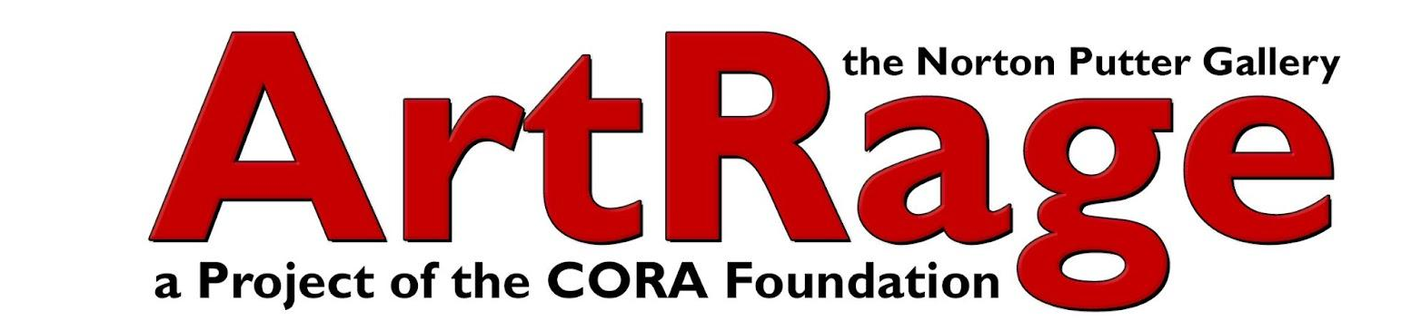

Dear
ArtRage Gallery’s annual summer fundraiser, The ArtRageous Extravaganza, returns on June 27, 2026, and we invite you to be part of this vibrant and impactful evening by contributing to our Silent Auction.
As our most important fundraiser of the year, this signature event brings together artists, supporters, and community members for a lively celebration featuring live music, food, drinks, and an exciting auction—all in support of ArtRage Gallery’s mission.
Your donation plays a direct and meaningful role in sustaining our work. With your support, ArtRage Gallery continues to present socially relevant art and showcase a diverse range of local, national, and international artists here in Syracuse. Proceeds from the Silent Auction help fund our exhibitions, film screenings, artist talks, workshops, community discussions, theater performances, poetry readings, author events, and more.
We would be truly grateful for your contribution and the vital role it plays in keeping our programming accessible, engaging, and impactful.
A donor form is enclosed for your convenience. Donations may be submitted by email or mail, or we would be happy to arrange a time to pick up your item.
If you have any questions, please don’t hesitate to reach out—we would love to connect.
Thank you for your generosity and continued support.
Warm regards,
Terry J. Eckert
Board President
ArtRage Gallery

