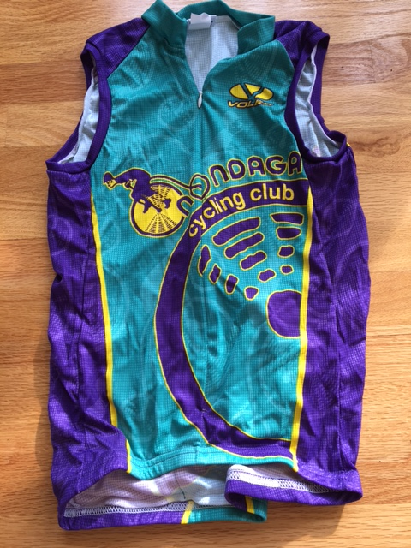

1 Men Sleeveless Race Raglan Med
1 Men Sleeveless Race Raglan Small
2 Women Sleeveless Raglan Small
2 Women Sleeveless Raglan Med
1 Women Short Sleeve Race Raglan Small
1 Women Short Sleeve Race Raglan Large
1 Women Short Sleeve Club Cut Small
1 Arm Warmers X-large
1 Race Raglan Shell Vest Small
1 Race Raglan Shell Vest Med

