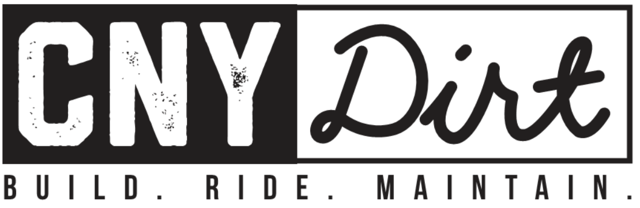

CNY-DIRT – GLAMP FOLLOW UP & THANK YOU

First and foremost, thank you to everyone for showing your support and supporting the GLAMP! The excellent turn out and successful fundraising effort reinforces what many of us already know, that we live in a great community with boundless opportunity for outdoor activities, specifically mountain biking. All in all we raised a total of $12,000 of funds to support the Plan development and have collected over 400 signatures of support for of the GLAMP.

Special thanks to our largest supporters and major contributors:

- Syracuse Bicycle
  - Fat bike raffle ticket donation - the largest single portion of funds raised!
  - Seed funding to develop initial plans and get the ball rolling!
  - Coordinating water bottle design and sale
- Bike Loft East
  - Donation of “Drag” donation for snow grooming!
  - Extending insurance coverage to grooming operations!
- Onondaga Cycling Club
  - Portion of initial seed funding to develop initial plans and get the ball rolling.
  - Special Thanks to Zeke Ronnow for outstanding coordination effort between CNY-DIRT and OCC.
- The Yard Coffee Shop and Event Center
  - Free use of the event center!
- Coast to Coast - Kendrick Schnell
  - Kendrick Schnell did an awesome job creating the art work for GLAMP promotional flyers.
  - Design and supply of GLAMP T-shirts.
- Rabin law firm
- SOS/ John Parker, M.D.
- Ricciardello Family
- Zipprich Family
- Bradshaw Blues
- Thule/ Chris Rine
- Chris Cavanaugh
- Voss Signs
- Buried Acorn Brewery
- Lady Bug Lunch Box Food Truck
- Taber Family
- Hill family
- Gloo Family
- Stans No Tubes
- NICA

GLAMP UPDATE:

Green Lake State Park is scheduling a public hearing and input period. It is tentatively scheduled for the last week of January 2019. CNY DIRT will send out notification when the date and location is final. We encourage anyone who can make it to attend in person to voice their opinion on use of the park addition . CNY DIRT has submitted the GLAMP petition with over 400 signatures to the park to make them aware of community support for mountain bike trail development in the park.

The GLAMP will be developed by a committee organized by CNY-DIRT board members and will include representatives from the NYS Parks, NYSDEC, Onondaga County, and other local government officials. Professional trail planners are also being engaged to provide guidance and assistance to create a high quality and effective trail plan. This effort will take some time and will be on going over the course of the next year. CNY DIRT will provide updates and drafts of the plan for your input. The International Trail Symposium is being held in Syracuse this spring. We are looking for opportunities to partner with the trail symposium to find low cost services and or content for the GLAMP.

The Park has recently Posted part of the new property which is open to the public. Hunting is permitted in this area so please be aware of that and wear blaze orange during hunting season. The land south of Route 5 has not yet been Posted by the Park.

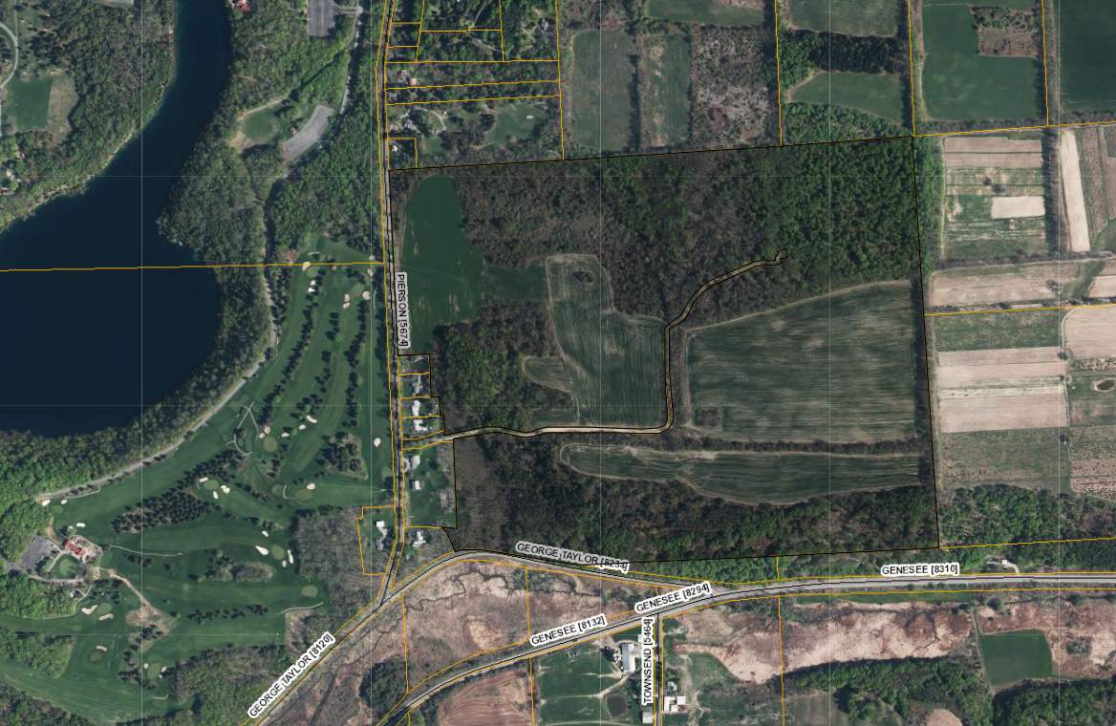
NEW GREEN LAKES PROPERTY EAST OF PIERSON ROAD.

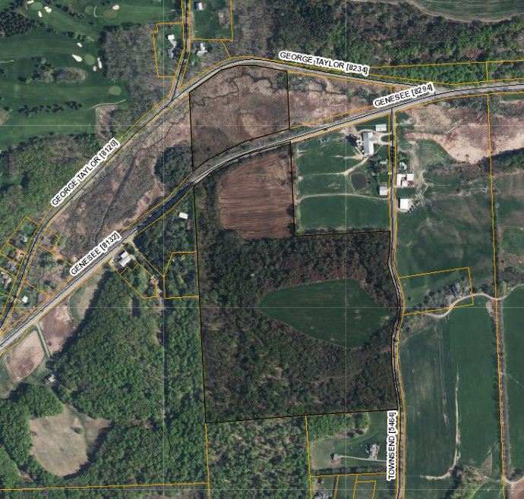
ADDITIONAL LAND PURCHASED BY THE PARK NOT YET POSTED

Green Lakes Trail Grooming Update:

CNY-DIRT will groom multi use trails/ bike legal trails starting this winter. Chris Cavanaugh of Roth racing received preliminary approval for grooming in Green Lakes in late 2018 and connected with CNY-DIRT to help in bring the grooming to life. Jeremy Clay / Bike loft East has made a significant contribution to this effort donating a drag for grooming, use of a snowmobile and covering the required insurance cost. Insurance is the most significant cost of the grooming operation. Steve Wilson and Jeremy Clay will be the primary groomers this winter. Grooming is planned to start late December and through the winter. Grooming will occur when there is at least 6” or more of snow on the ground and touch ups as needed. More details to come regarding the specific trails to be groomed.

