I am ride leader for Memorial Day ride will have a few maps
But bring your own fit file

Fish hatchery closes at 4pm
If you are returning after, park on the grass outside the gate



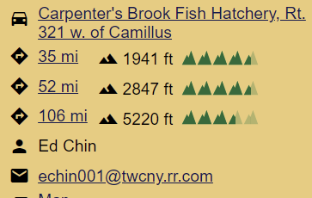

-----Century water stop
40 miles at Clyde Martins grocery outlet
Stopped there last year
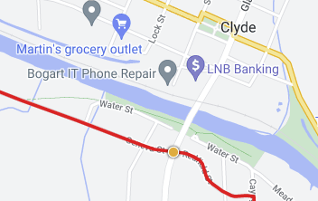

45 mile- country store
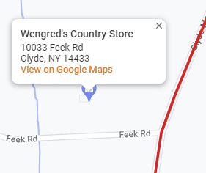

60 Mile Rose Fire Dept
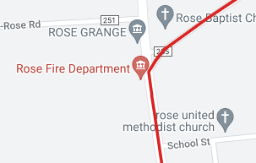

77 Mile Duck Lake Campgrounds

96 miles Sunoco Gas Station
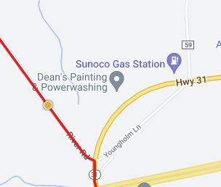

97 Mile Jordan- likely encounter parade
Dale joined in last year
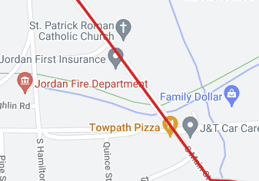

53 mile ride

35 mile-Old hickory farm, a wedding venue, maybe water
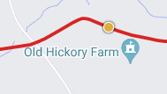

43 mile- Sunoco Gas Station
(see above pic)

35 mile ride

12 mile- Mary Barn Market

25 mile- Sunoco Gas
(see pic above0

