Century

20 miles Sunoco gas station
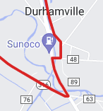

32, 66 miles New London Food Mart
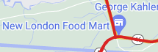

45 miles Stewarts shops
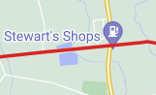

53 miles Delta Lake State park
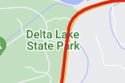

57 Miles Circle K
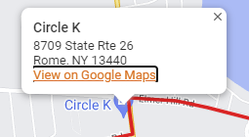

86 mi Byrne Dairy
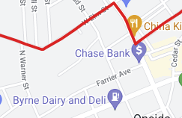

93 Market, near Graystone Castle
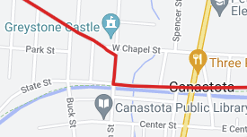

63 Mile ride

20 mi Sunoco Station Durhamville

45 Mi Circle K

53 mi Market near Graystone Castle

52 Mile ride

20 miles Sunoco gas station

48 Miles Dads ice cream
